**IT – 2120**

**Probability and Statistics**

**IT24104068**

**Lab – 10**

**R Script**

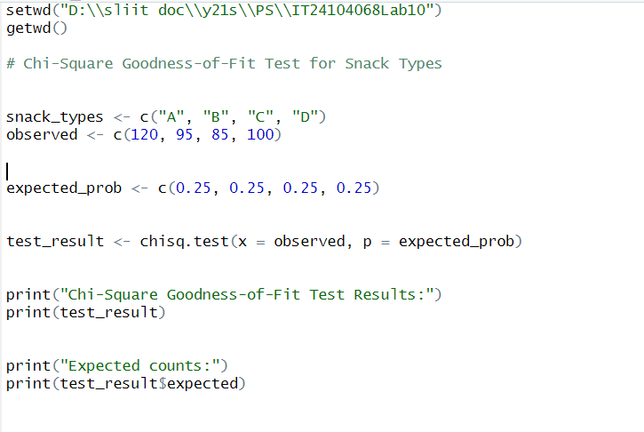

**Answers**

**Final Data**

